**Object Oriented Programming LAB**

**Name: Sreelakshmi M Nair**

**Roll No: 40**

**Batch: RMCA**

**Date:1-06-2022**

**Experiment No.: 22**

**Aim**

 Program to create a generic stack and do the Push and Pop operations.

**Procedures**

**Source Code**

import java.util.*;

class operations{

public void operation()

{

int top =-1,ch,n,e;

Scanner inp = new Scanner(System.in);

System.out.println("Enter Size of Stack");

n = inp.nextInt();

int size=n-1;

int[] arr = new int[n];

do {

System.out.println("\n=============\n MENU : \n1.push \n2.pop \n3.Display \n4.Exit \n=============");

System.out.println("Enter your choice");

ch = inp.nextInt();

switch(ch)

{

case 1 :

if(top == size)

{

System.out.println(" *** Stack is Full *** ");

}

else

{

System.out.println("Enter Element : ");

e = inp.nextInt();

top++;

arr[top] =e;

}

break;

case 2 :

if(top == -1)

{

System.out.println("\n*** Stack is empty *** ");

}

else

{

System.out.println("\n"+ arr[top] + " is removed ");

top--;

}

break;

case 3 :

if(top == -1)

{

System.out.println(" *** Stack is empty ***");

}

else

{

System.out.println("\n*** Stack : ***\n");

for(int i=top;i>=0;i--)

{

System.out.println(" " +arr[i]);

System.out.println("-----");

}

}

break;

case 4 :

System.exit(0);

default : System.out.println("Invalid Choice");

}

}while(ch !=4);

}

}

public class Menudriven {

public static void main(String[] args) {

operations obj = new operations();

obj.operation();

}

}

**Output**

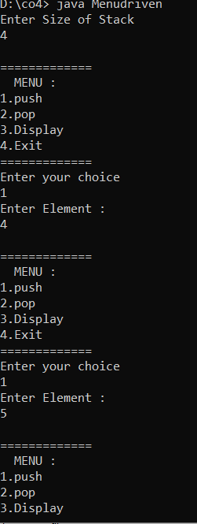

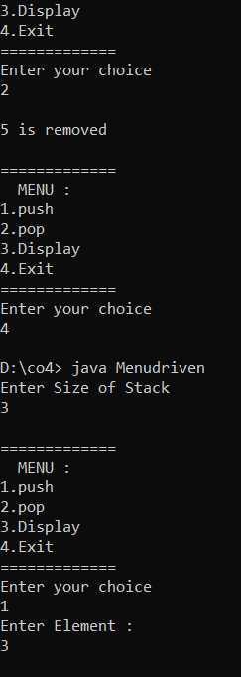

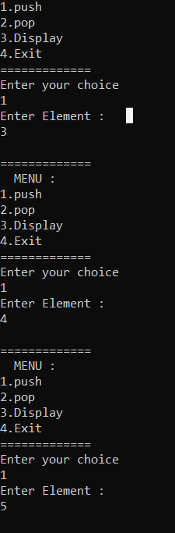

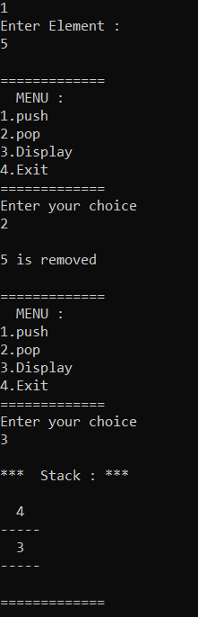

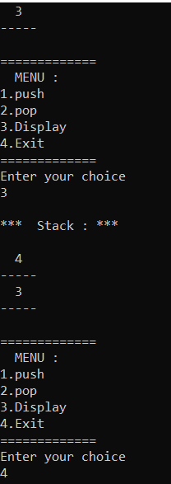

**Experiment No.: 23**

**Aim**

Find the average of N positive integers, raising a user defined exception for each negative

input.

**Procedures**

**Source Code**

import java.util.Scanner;

public class Num{

    public static class InvalidNumberException extends Exception {

        public InvalidNumberException() {

            super("Please provide a valid number!");

        }

    }

    public static void main(String [] args){

        Scanner sc=new Scanner(System.in);

        int c,num,sum=0;

        double avg;

        System.out.println("enter the count");

        c=sc.nextInt();

         System.out.println("enter the Numbers");

        for(int i=0;i<c;i++){

            try{

                num=sc.nextInt();

                if(num>0){

                    sum+=num;

                }else{

                    i--;

                    throw new InvalidNumberException();

                }

            }

            catch(InvalidNumberException e){

                System.out.println(e.getMessage());

            }

        }

        System.out.println("sum is"+sum);

        System.out.println("avg is"+sum/c);

    }

}

**Output**

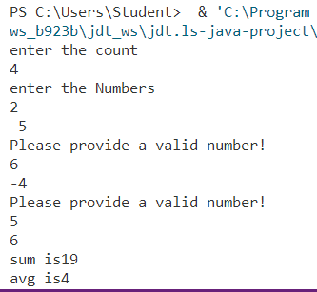

**Experiment No.: 24**

**Aim**

Define 2 classes; one for generating Fibonacci numbers and other for displaying even numbers in a given range. Implement using threads. (Runnable Interface).

.

**Procedures**

**Source Code**

import java.util.*;

class fibonacci implements Runnable {

    int l;

    fibonacci(int n) {

        l = n;

    }

    public void run() {

        int c;

        int a = 0, b = 1;

System.out.print("Fibonacci:");

        System.out.print(a + " " + b);

        for (int i = 0; i <= l; i++) {

            c = a + b;

            System.out.print(" " + c);

            a = b;

            b = c;

        }

    }

}

class even implements Runnable {

    int l;

    even(int n) {

        l = n;

    }

    public void run() {

System.out.print("Even Number:");

        for (int i = 0; i <= l; i++) {

            if (i % 2 == 0)

                System.out.print(i + "  ");

        }

        System.out.println("");

    }

}

class Fibi{

    public static void main(String args[]) {

        Scanner sc = new Scanner(System.in);

        System.out.println("Enter Limit :");

        int l = sc.nextInt();

        even e = new even(l);

        Thread T2 = new Thread(e);

        T2.start();

fibonacci f = new fibonacci(l);

        Thread T1 = new Thread(f);

        T1.start();

    }

}

**Output**

